

*FINAL PRJECT - WORD*

*TIC*

*GROUPE 91 :*

* *AMAROUCHE Yacine*
* *GACI Nour*
* *AKNOUCHE Soundes*
* *KLAA Nour El Imane*

Table of Contents :

I. INTRODUCTION : 3

II. PROGRAM : 4

− Word – CHAPTER 1 : 4

− Excel – CHAPTER 2 : 4

− Latex – CHAPTER 3 : 5

− Google Services / PowerPoint / HTML&CSS – CHAPTER 4 : 5

− Git & GitHub – CHAPTER 5 : 6

III. ASSIGNMENTS : 7

− CHAPTER 1 – HOMEWORK : 7

− CHAPTER 2 – HOMEWORK : 7

− CHAPTER 3 – HOMEWORK : 8

− CHAPTER 4 – HOMEWORK : 8

− CHAPTER 5 – NO HOMEWORK : 8

IV. FINAL EXAM : 9

1. Word Exercise: 9

2. Latex Exercise (Overleaf): 9

3. PowerPoint Exercise: 9

4. Git/GitHub Exercise: 9

5. Excel Exercise: 9

V. SUMMARY : 10

# INTRODUCTION :

To empower Computer Science students at University of Science and Technology – Houari Boumediene, an online course named Information and Communication Technologies (TIC) has been introduced. In this virtual class, students delve into various computer programs designed to simplify office tasks. They not only grasp the basics but also acquire advanced skills, using the course as a guide to navigate a variety of tools such as text editing, organizing information, sending emails or files, and even creating websites and dynamic presentations.

Throughout the course, students explore several practical programs. They become familiar with Google tools like Docs, Sheets, and Slides, facilitating collaborative project work. Additionally, they delve into Git and GitHub, essential tools for managing and tracking changes when collaborating on significant projects.

The course also introduces students to Microsoft tools, including Word, Excel,

PowerPoint, and Outlook. These tools prove invaluable for handling documents, spreadsheets, presentations, and managing emails efficiently.

The importance of these tools cannot be overstated. Learning the tools in the TIC course is really important for the student's future. In today's world, being proficient with these tools is like having a special skill that aids the student in school and at work. Knowing how to edit text, organize things, and collaborate with others using tools like Google Docs is crucial for effective communication and project management. Understanding Git and GitHub is akin to knowing how to work together on significant computer projects. Microsoft tools like Word, Excel, PowerPoint, and Outlook serve as super useful helpers for getting work done.

It's not just about school; these skills are like a toolkit for future jobs. They make the student flexible and ready for whatever challenges might be faced in the world of computers and technology.

The primary goal of the TIC course is to establish a robust foundation for students. It equips them with the skills needed not only for their academic endeavors but also for future professional roles in the field of computer science. Beyond covering the basics, the course aims to empower students with the practical skills necessary to excel in the dynamic world of computer science and adapt to emerging challenges.

# PROGRAM :

The module is divided into five chapters, each introducing essential tools for office tasks. These chapters aim to enhance students' skills and competence. The content covers:

## Word – CHAPTER 1 :

 In the Word chapter, students explore Microsoft Word from basic text editing to advanced features like creating tables and adding images. They also learn to use shapes and smart art for comprehensive projects. The module aims to make students proficient in using Word for various university and work tasks, enhancing their skills and capabilities.

|  |  |
| --- | --- |
| **TOOL** | **IMPORTANCE** |
| Word | Essential for creating professional documents and fostering collaboration, offering versatile features for efficient communication in academic and professional contexts. |

## Excel – CHAPTER 2 :

In the Excel chapter, students dive into Microsoft Excel, covering basics like entering data and progressing to advanced features such as creating tables, charts, and using formulas. The module aims to make students proficient in using Excel for diverse school and work tasks, equipping them with valuable skills for data management and analysis.

|  |  |
| --- | --- |
| **TOOL** | **IMPORTANCE** |
| Excel | Essential managing data, creating tables, charts, and using formulas, enhancing efficiency in academic and professional tasks. Excel proficiency ensures accurate data analysis and is widely applicable across various fields. |

## Latex – CHAPTER 3 :

In this chapter, we explore an alternative method for text editing, similar to what we do in Word, but with a different approach used in Latex due to the contrast between Word and Latex. Microsoft Word, with its user-friendly graphical interface, is great for general documents. On the other hand, Latex, being a typesetting system, uses mark-up language for precise formatting, making it a preferred choice for intricate academic and scientific papers.

|  |  |
| --- | --- |
| **TOOL** | **IMPORTANCE** |
| Latex | Essential for precise document formatting in academic and scientific contexts, learning Latex is crucial. Its advanced typesetting capabilities make it preferred for creating complex and professional-looking papers. |

## Google Services / PowerPoint / HTML&CSS – CHAPTER 4 :

In this chapter, students explored Google Services like Docs, Sheets, and Gmail, followed by a quick introduction to PowerPoint, where they learned to create presentations with ease, due to its familiar interface shared with other Microsoft Office programs. Additionally, the students delved into HTML & CSS, discovering how to build basic websites by inserting texts, tables, images, and various elements. This diverse set of skills provides a well-rounded understanding of digital tools for effective communication and web creation.

 

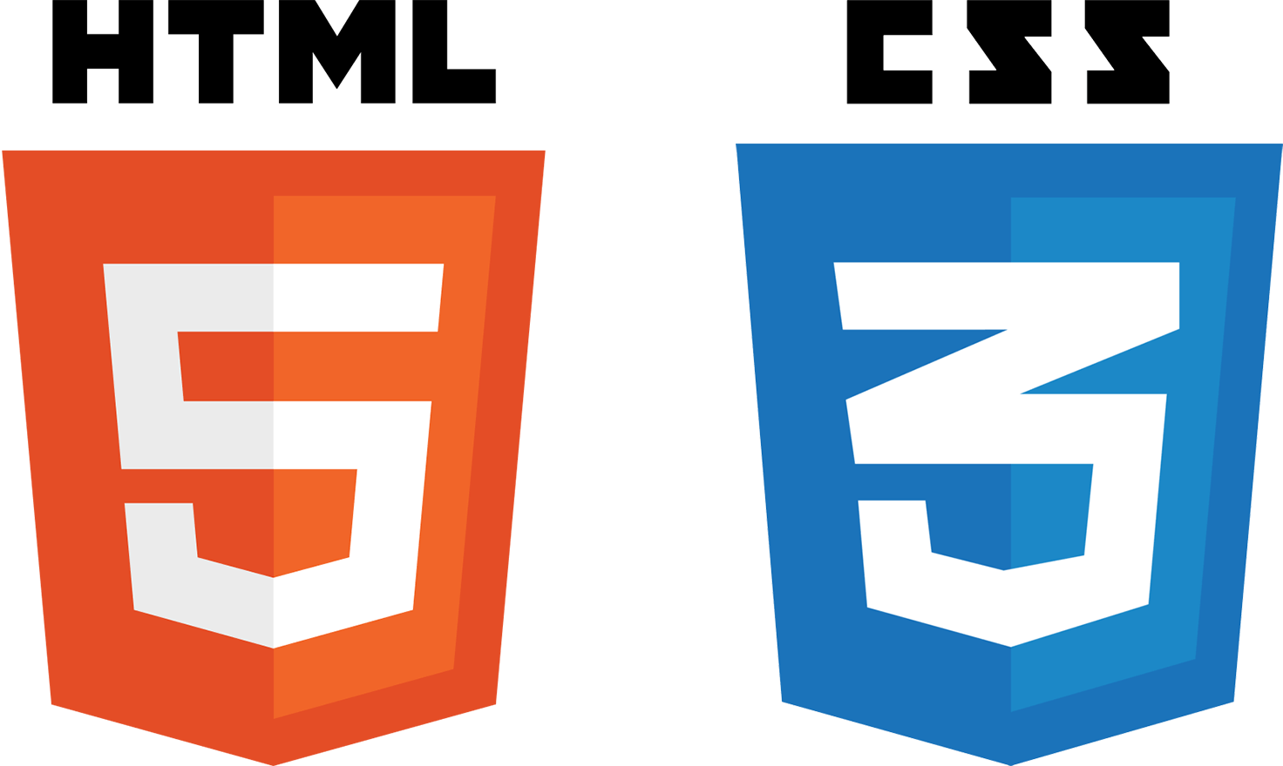

|  |  |
| --- | --- |
| **TOOL** | **IMPORTANCE** |
| Google Services | Essential for collaboration, mastering Google services streamlines document creation in academic and professional contexts. |
| PowerPoint | Essential for impactful presentations in academic and professional settings, mastering PowerPoint enhances communication and visual representation skills. |
| HTML&TCSS | Essential for basic website creation, mastering HTML & CSS enables the insertion of text, tables, images, and more, fostering foundational web development skills. |

## Git & GitHub – CHAPTER 5 :

In this chapter, students learned about Git and GitHub, tools that enable collaborative project work without disruptions. GitHub, a platform for saving and sharing code, simplifies teamwork, fostering collaboration to build innovative projects together. The goal

of learning Git & GitHub is to make collaboration easy for teams, facilitating the creation of exciting projects collectively



|  |  |
| --- | --- |
| **TOOL** | **IMPORTANCE** |
| Git & GitHub | Essential for collaborative coding, mastering Git & GitHub streamlines teamwork and facilitates efficient version control, crucial in software development and collaborative projects. The knowledge gained empowers effective contribution to shared code repositories. |

# ASSIGNMENTS :

At the conclusion of each chapter, the instructor assigns a homework to the students, and the following is a summary of each homework assignment.

## CHAPTER 1 – HOMEWORK :

For the first chapter's homework (Word), students are tasked with creating a project involving text editing and utilizing various formatting elements such as italic, bold, and underlined text. Additionally, they are instructed to create multiple tables with diverse styles, employ the SmartArt function, incorporate forms, and integrate equations into their project.

## CHAPTER 2 – HOMEWORK :

For the second chapter's homework (Excel), students are required to create an Excel project with multiple sheets. On the first sheet, they should craft a comprehensive table containing the full names of class students along with their exam notes. Using calculation operations, they are to determine the average note for each student. Adjacent to this table, a smaller one should showcase functions defining the highest note, the lowest note, the class average, and the total number of students.

On the second sheet, students are tasked with constructing a registration form where users can modify the profile, and the information updates automatically without altering the form. This form is linked to a table, created in another sheet, containing profiles and associated information, utilizing functions like VLOOKUP.

On the last sheet, the instructor provided a flight list, instructing students to reorganize it based on specific criteria using Excel's filtering option.

## CHAPTER 3 – HOMEWORK :

For the third chapter, the instructor tasked the students with a comprehensive Latex project consisting of multiple papers. On the first paper, they are required to create a page with their personal CV encompassing a personal profile picture, personal information, academic history, and competencies. The second paper should feature a cover letter with all necessary details. On the third paper, students are to construct a table containing flight list information. The final paper evaluates their knowledge of creating bullets and sub-bullets.

## CHAPTER 4 – HOMEWORK :

In the fourth chapter, the instructor assigned a comprehensive project to the students. The first component involves preparing a presentation on "An Efficient Web Search," limited to 8 slides. The presentation should cover key topics such as existing search engines, statistics on search engines, and efficient methods for searching information on the web.

The second part of the project entails creating a CV using HTML and CSS. Students are instructed to use the same template as the one employed in Latex.

## CHAPTER 5 – NO HOMEWORK :

In the final chapter, the instructor did not assign any homework to the students.

# FINAL EXAM :

At the end of the semester, students will face a final online project for the TIC (Information and Communication Technologies) module, forming groups to collaboratively complete exercises from each chapter, excluding HTML & CSS:

## Word Exercise:

- Task: Prepare a TIC report, covering Google services, Microsoft tools, Git, and GitHub.

- Requirements: Front page, content table, multiple pages (at least 8), tables, and pictures.

## Latex Exercise (Overleaf):

- Task: Replicate the content of Exercise 1 using Latex, emphasizing the differences between Word and Latex.

## PowerPoint Exercise:

- Task: Create a presentation summarizing the TIC module, based on the content of Exercise 1.

## Git/GitHub Exercise:

- Task: Use Git/GitHub to set up and manage the project. All files go to one GitHub repository, with each student pushing their respective files. Submission via a Google Form.

## Excel Exercise:

- Task: Answer 4 questions involving tables, multiple Pivot tables, tables with functions, and graphs.

Collaboration among students is crucial for the project, fostering communication, teamwork, and task division. Successful communication and effective collaboration within the specified time frame will contribute to earning higher points in the exam, emphasizing the importance of interpersonal and time management skills.

# SUMMARY :

The TIC (Information and Communication Technologies) module aimed to equip students with essential digital skills and knowledge. The primary objective was to familiarize them with various tools, including Google services, Microsoft tools, Latex, Git, GitHub, and Excel, fostering proficiency in tasks ranging from document creation to collaborative coding.

Throughout the module, students learned how to edit texts, create presentations, build websites, and efficiently navigate diverse software. The emphasis on collaboration, evident in exercises and the final project, taught students the importance of effective communication and teamwork. They were tasked with collaborative projects, including a comprehensive final exam project that encouraged students to divide tasks, communicate efficiently, and manage time effectively.

This collaborative approach not only enhanced technical skills but also emphasized the significance of interpersonal and organizational abilities. By providing hands-on experience with real-world tools and projects, the TIC module prepared students for the demands of academic and professional environments, fostering a holistic development that goes beyond technical proficiency.

THANKS FOR

READING